Run The Application

|  |  |
| --- | --- |
| Date | 25 November 2022 |
| Team ID | PNT2022TMID43214 |
| Project Name | AI-powered Nutrition Analyzer for FitnessEnthusiasts |

* Open the anaconda prompt from the start menu.
* Navigate to the folder where your app.py resides.
* Now type the “python app.py” command.
* It will show the local host where your app is running on <http://127.0.0.1.5000/>
* Copy that localhost URL and open that URL in the browser. It does navigate to where you can view your web page.
* **Enter the values, click on the predict button and see the result/prediction on the web page.**
* Then it will run on localhost:5000

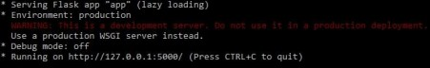

Navigate to the localhost (http://127.0.0.1:5000/)where you can view your web page.

Click on classify button to see the results.

**Output screenshots:**



